**MULTIPLICATION OF NUMBERS**

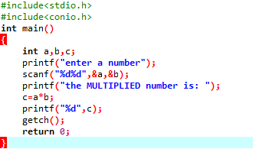

**OUTPUT**

